**Technical Documentation (Installation guide/Manual)**

**App guide**

1. First go to <https://github.com/santosh2403/RP-Automated-Car-Plate-Recognition-System.git>
2. A screenshot of a computer

   Description automatically generated with medium confidenceDownload the RP-ACRS.apk in the repository
3. On the android phone Go to where the file is downloaded and click on the app to install.

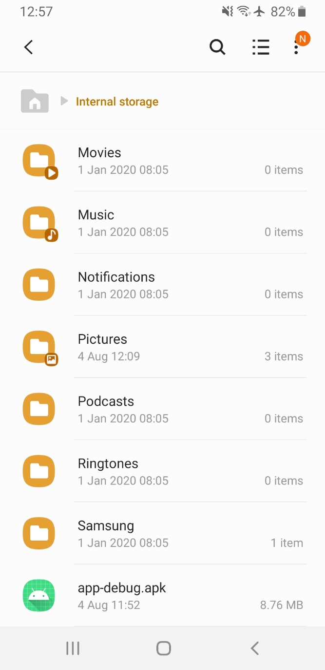

1. Click on install button to begin the installation of the app.

1. Wait for the app to install

‘

1. Once the app has installed, click open to open the app.

1. You should see the main screen of the app like so.

1. From here refer to the Application manual/ user guide